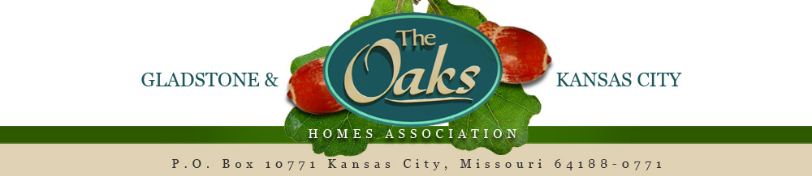

2017 Annual Meeting Minutes
2017 Annual Meeting called to order at 9:10am by chair Larry Stitt
Homeowners Represented at Meeting: Baum, Keith; Beamer, Juliana; Bee, Robert; Berard, Peter; Brown, Susan; Bui, Thi; Carter, Charles; Carter, Linda; Coomes, Cristina; Corlew, Kevin; Corlew, Patricia; Conrelius, Shirley; Davis, Cara; Day, James; Engelhardt, Alvin; Featherston, Jon; Floyd, Chris; Gahr, Patricia; Gottstein, Conrelius; Grenko, Carol; Hadaway, Kathy; Hilton, Charise; Jones, Marcus; Joy, Jessi (Majors, Jessi); Khan, Shamim; Kincaid, Mike; Kluender, William; Langton, Tom; Nyquist, Stuart; Patterson, Janice/Larry; Patton, Drew; Pray, Jeremy; Richmeier, Betty; Rizzolo, Gary; Schmidt, George; Stitt, Larry; Sulzer, John; Truong, Paul; Van Dyke, Robert; Wallace, Chris; Yarber, Kyle; Zeller, Cheryl
Introductions of Board Members proceeded by Chair Stitt
Chair Stitt called upon guest speaker State Representative Kevin Corlew. Representative Corlew introduced himself and provided information regarding state ongoings inclusive of state agency issues and provided contact information. Representative Corlew opened the floor for questions from homeowners.
Chair Stitt called upon guest speaker Gladstone City Council candidate Kyle Yarber. Kyle informed the homeowners about his plans and ideas for the City of Gladstone. Questions regarding the nature trails and quality of life were entertained.
Chair Stitt called upon guest speaker Gladstone Public Works Tim Neibergall. Tim made mention of the walking trail in the neighborhood to simply discuss the potential of infrastructure updates inclusive of a potential walking trail, culvert for storm water and overlay of the roads and potholes to be completed by Kansas City. Tim further discussed the Gladstone’s citizens based strategic plan. Tim addressed concerns and questions regarding contentions among homeowners. Homeowners expressed appreciation to Gladstone and to Tim Neibergall.
Treasurer Melinda Burnett presented the 2016 and 2017 budget to the homeowners. Chair Stitt made mention of additional budgeted needs regarding sprinkler and printing. Homeowners expressed appreciation for the additional collection of past due balances. Chair Stitt called upon the homeowners to approve the budget. Mike Kincaid motioned to approve the annual budget. Discussion ensued regarding additional expenses and desires. Bob Bee 2nd the motion, the vote ensued and passed unanimously.
Acting Secretary Andrew Davis read 2016 annual meeting minutes. Davis requested approval of annual meeting minutes from 2016. Bob Bee moved to approve annual meeting minutes, motion 2nd by Larry Patterson. Homeowners unanimously moved to approve the 2016 annual meeting minutes.
Chair Stitt opened the floor for discussions and concerns among homeowners. Snow removal for front entrance was discussed and desired. Chris Wallace discussed his background knowledge in snow removal for such. Board of Directors to proceed with feasibility study to determine options available.
Acting Secretary Andrew Davis called upon the homeowners to nominate and vote on three new board positions.
Nominations were held, homeowners nominated were: Thi Bui, Cara Davis, and Larry Stitt nominees accepted their nominations and the homeowners voted with unanimous support.
2017 Board of Directors met for selection of officers. Officers’ positions will be:
Larry Stitt – Chair
Gary Rizzolo – Vice Chair
Cara Davis – Treasurer
Thi Bui – Secretary
Marcus Jones – At Large

